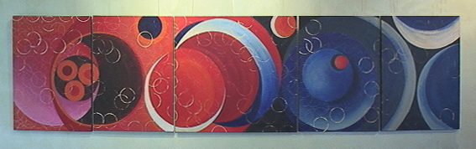 Kundalini Yoga and Art with Cindy Male

My relationship with each of my yoga students involves teaching, encouraging, motivating, directing, interpreting, and evaluating an individual’s effort towards the development of their own self-awareness. In all aspects, each student is reminded to extend self, but gradually, gently, and through patience with their body’s performance. Regular practice and integration of yoga into one’s lifestyle WILL bring about change. This is to confirm that the undersigned will not hold Cindy Male nor Cindy Male Kundalini Yoga and Art nor anyone connected with this studio responsible for any injury during the yoga and or art workshops or sessions.

Thank you.

Your Name________________________ Date___________
Address__________________________________________
Phone___________________ e-mail________________________

